Heatwole-Carroll, Cedric

ETR 164

Verrier

8 Mar 18

**Research and Concepts**

My idea was a pretty basic one. Really I was completely unsure of what to do for this project that hasn’t already been done, or that would be specifically useful to me that I don’t already have on my desktop. My idea is a simple one: **program a Raspberry Pi has a central media hub for games, and movies when my internet is unavailable.**

* Download a basic R-Pi OS, such as Noob
* Research console emulators compatible with R-Pi
* Research media hub software compatible with R-Pi
* Design a basic interface in java or C++ script for users to navigate files.

The set up for a Raspberry Pi is easy enough. There are countless tutorials and walkthroughs online that will help me easily accomplish this goal.

<https://www.raspberrypi.org/help/noobs-setup/2/> ← This was the tutorial I used during class to set up the R-Pi for the IRC server. Following this step by step will ensure my success.

I have found multiple Media Hub software that I can use for this project. Following [this](https://www.makeuseof.com/tag/4-ways-set-up-raspberry-pi-media-server/) link, I was able to see the various software that people have used for just this instance. Kodi, ReadyMedia, OpenMediaVault, and Plex Media Server.

All of these are great, but how would I incorporate them into a single interface with retro gaming?

[Here](https://www.pcworld.com/article/3190347/gaming/how-to-build-a-raspberry-pi-retrogaming-emulation-console.html) I have found an entire DIY guide and suggestions for just that! Luckily most of those who play with Raspberry Pi’s are gamers, and this concept was realized very early on.

This is my first concept of a menu. Basic but gets the job done, I suppose. VERY Subject to change.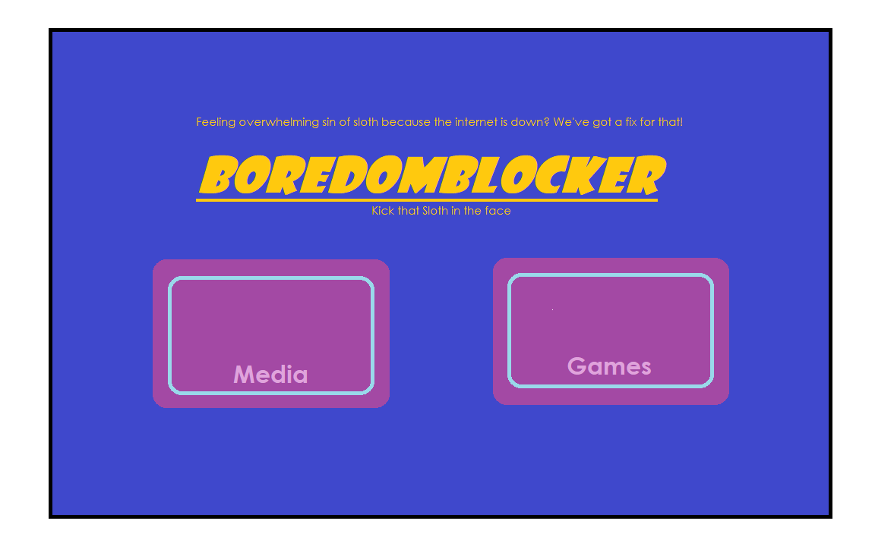

Upon doing more research, I found a particular emulator that has solved all of my questions.

<https://www.recalbox.com/> RECALBOX! Apparently someone else also had the same idea as me. However I feel as though this is incomplete. I have many more game ROMs that this program doesn’t, so I’ll have to add my own. In time I am going to study the interface and see if there are any changes I wish to make.

RecalBox comes downloaded with Kodi, so it doubles as a media server and an emulator with an easy to navigate set up and menu. I will look more into this as the time allows.